**Dashboard Comparison Report**

**Chris Johnson February 2016**

**Version 0.1**

|  |  |  |
| --- | --- | --- |
| Version number | Description | Date of version |
| 0.1 | First draft | 10th February 2016 |
|  |  |  |

**Distribution List**

|  |  |  |
| --- | --- | --- |
| Name | Position | Date sent |
| Hassan Mamdani | Research Scientist Computational Chemist | 10th February 2016 |
| David Franklin | Head of Financial Planning and Analysis | 10th February 2016 |
| Jacqueline Richard | Head of Financial Reporting | 10th February 2016 |
|  |  |  |
|  |  |  |

**Introduction**

Within Prometic, there is an increasing need to get analytics quickly. The board reports that are currently written manually and have to be compiled and delivered by hand. The decision has been made to investigate dashboard reporting tools as a way of addressing these issues. This review began in November 2016 and consists of a subset of available dashboard reporting tools. The process of this review was

* Identify Prometic’s Dashboard requirements
* Draw up a shortlist of products to trial
* Perform a literature review identifying the products strengths and weaknesses in relation to Prometic’s requirements
* Investigate market review of products (Gartner Inc.)
* For the top three products identified in the literature review, perform an in-house technical review, updating the product strengths based off of this

David Franklin initiated and sponsored this project, with Chris Johnson performing the research.

**Requirements**

Should be able to connect to a SQL database

The ERP System Syspro uses SQL databases to store data – all the dashboards required will need to access Syspro to provide the results needed.

Should be able to connect to Salesforce

Forecasts for sales in PBL are held within Salesforce, the solution should be able to pull this information and combine it with the data from Syspro.

Should be able to import and export from excel

Import – As a lot of data is held in excel currently by the finance team, data should be able to be imported from Excel and combined with other data sources, allowing for quick access to changing data behind dashboards that require manual intervention.

Export – With the finance team currently skilled in the use of Microsoft Excel, it will be quicker in some cases for them to deal with data held in excel. The solution should allow results to be sent to Excel for manual manipulation.

Should be presentable via the web

The solution should be forward-looking; without having to install another piece of software on an employee’s computer, the reports should be accessible via the internet.

ETL (Extract, translate, load) should be part of the solution

ETL is the process of taking data from a source system (such as SQL or Salesforce), adding relationships, context and logic to the data to prepare it for reporting. ETL can become a major project in its own right if not considered at the beginning of a project. With this in mind, any solutions that provide this functionality without the purchase of additional software would have a large advantage in terms of cost, development and maintenance.

Dashboard should be interactive allowing users to query information

Reports/Dashboards that are provided should allow users to interact with the data and interrogate it with a minimum of training. Currently only static reports are provided but any further questions need to be answered by either writing a new report or amending the existing one which has to be done by a developer and is slow when compared to the dashboard options available. This change will make answers to questions available in seconds and minutes instead of hours and days.

Performance should be maintained so an equal service is presented globally

With an audience based in Canada, the UK and internationally travelling the dashboards should be equally responsive regardless of where the system is being accessed from.

The system should require no more than 10 minutes to demonstrate and train on for users

The solution should be intuitive to use, without having to attend a lengthy training course a user should be able to interrogate the data and create their own reports within 10 minutes.

**Other Requirements**

Capturing of budget data

Ideally, in future iterations, dashboards would be made available to business managers with the expectation that given the information for previous years they would be able to write their own budgets for review by Finance. A system that could capture this data would be preferable.

Financial Forecasting

A project for the future is to automate the process of financial forecasts and integrated into dashboards. To support this, the solution should include an extensive analysis platform.

Open up access for other applications to other parts of the business

Dashboards are initially to be looked at for the Finance department and the board, then being rolled out to Sales with a view to look at all parts of the business. This requires security to only show relevant information.

Dashboards should be viewable on mobile devices

The solution should be forward-looking; in the future it will be required that dashboards will be available on mobile platforms including but not limited to Apple, Android and Windows devices.

Screen sharing for board meetings should be available

With the data to be made available for use in Board meetings, the solution should be robust enough to allow presentations to be made from the dashboards.

**Other Considerations**

Solution should be well supported (more than one vendor/source of knowledge)

Any product implemented should be easy to maintain, however if outside consultancy is required there should be a large number of firms that can provide this experience.

Solution should be well rated (reviewing Gartner BI reports)

Any solution should be recognised by the industry as a leader in its field, the company Gartner Inc. provides this data and as part of this review the solutions on the shortlist will be checked against the industry respected review.

Solution should support cross-dashboard branding (having a central list of colours/themes)

Branding for the company should be included in all reports and dashboard, the ideal solution would enable this to be held centrally so that changes can be effected quickly without wasting effort changing each dashboard individually.

**The Shortlist**

**Qlik**

This entry was included based off successful deployment and experience of Chris Johnson at previous companies and its position.

**Tableau**

This entry was included as Tableau has been a market leader for Business Intelligence for the past six years.

**Spotfire**

This entry was included as it has a large market share within the pharmaceuticals industry in the UK.

**SiSense**

This entry was based off of Literature that promised a lot of features that were attractive.

**Ezora**

This company approached Prometic suggesting that they would be able to provide the functionality required.

**Notable mentions that did not make the shortlist**

**Microsoft (SQL Reporting Services, Power BI)**

Based off past experience, it was determined that the amount of work, money and staff required to implement and maintain a full Business Intelligence stack would not give enough return on investment for the company.

**Syspro Dashboards**

Dashboards as presented within Syspro are read only, not allowing interaction with the data or exporting to excel, following discussions with K3 we don’t believe that the functionality meets requirements.

**Gartner Quadrant**

The Gartner Magic Quadrant (MQ) is a series of market research reports published by Gartner Inc., a US-based research and advisory firm. The Magic Quadrant aims to provide a qualitative analysis into a market and its direction, maturity and participants.

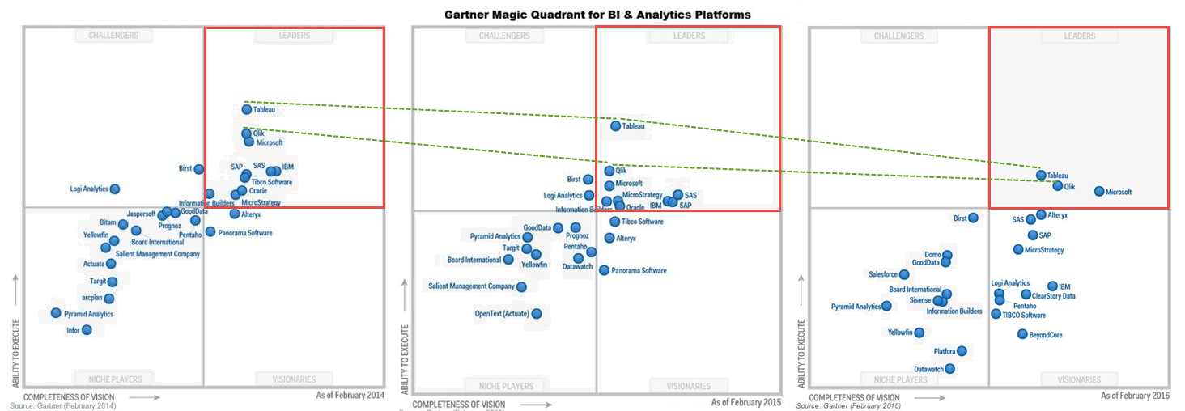Here are the last three years of Magic Quadrants for BI & Analytics Platforms.

**Supplier Descriptions**

These descriptions are copied from the “Magic Quadrant for Business Intelligence and Analytics Platforms” By Gartner 2016.

**Qlik**

Qlik offers governed data discovery and analytics via its two primary products: QlikView and Qlik Sense. Its in-memory engine and associative analytics allow users to see patterns in data in ways not readily achievable with straight SQL. Both QlikView and Qlik Sense are often deployed by lines of business as well as by centralized BI teams that are building applications for governed data discovery. Qlik Sense was officially released in September 2014, based on modern APIs and an improved interface, and became the vendor's lead product for new customers in 2015. Qlik Sense Cloud and Qlik Data Market were also released in 2015. Qlik Analytics Platform (QAP) is a solution for developers to build and embed content using the same redesigned engine and Web services APIs upon which the vendor built Qlik Sense. QlikView and Qlik Sense customer experience scores were considered in this evaluation, but Qlik Sense was the primary focus for our product evaluation.

Qlik is positioned in the Leaders quadrant, driven by a robust product and high customer experience scores (based on an assessment of Qlik Sense). Its market execution has been tempered by confusion in the marketplace around QlikView and Qlik Sense. This should improve in 2016, with a stronger product, changes in executive leadership and clearer messaging, although its strong partner network may hinder execution of the new positioning of Qlik Sense as the vendor's lead product. The key components of Qlik's overall vision — a marketplace, governed data discovery with users able to readily promote content, and increasingly smart data preparation — position it as one of the most complete solutions.

**Qlik**

**Strengths**

* Qlik is highly rated for ease of use, complexity of analysis and business benefits (according to its reference customers). Compared with its chief competitors, Tableau and Microsoft, Qlik scores significantly higher on complexity of analysis — which we attribute to its stronger ability to support multiple data sources, a robust calculation engine and associative filtering and search.
* With a modern BI architecture, power users may become the predominant content developers, instead of IT developers. In this regard, user enablement is more important as users need just-in-time training, online tutorials and community-based resources to support them. Qlik scored in the top quartile (of this Magic Quadrant's vendors) for user enablement. This score should improve further in 2016, because Qlik recently introduced its Qlik Continuous Classroom.
* With a rapid implementation approach and an in-memory engine that can handle complex data sources and applications, Qlik scored in the top third for product success. In this regard, Qlik can be used as an extension to a data warehouse or as a data mart for customers that lack a data warehouse. This vendor has continued to introduce smarts into the product to simplify the data load and modelling process. Customers most often choose Qlik for its ease of use, functionality and performance.
* Qlik's strong partner network (of more than 1,700) across multiple geographies is a key ingredient in ensuring customer success, which improved in 2015. Product success also improved significantly this year, which can most likely be attributed to a more mature product and improved partner enablement.

**Qlik**

**Cautions**

* Cost of software was cited as a barrier to adoption by 29% of Qlik's reference customers, putting it in the top quartile for this barrier. Qlik Sense uses token-based pricing, which closely aligns to a named user but with some concurrency supported. The degree to which Qlik is considered expensive depends on the point of comparison. Based on user reference responses from last year's Magic Quadrant, Qlik's licensing is competitively priced relative to Tableau and is less costly than that of the mega vendors. However, in larger deployments (of more than 500 users), its pricing is 70% higher than chief competitor Tableau and almost double Microsoft's three-year license fee. Recent contract reviews by Gartner do show increased flexibility in negotiating terms for larger deployments.
* Qlik scored slightly below average for customer support (which includes level of expertise, response time and time to resolve). There has, however, been a slight improvement over last year's support scores. Qlik also recently introduced Proactive Support, in which it transparently collects data from customer log files to proactively look for performance issues or events that may impact the server.
* Twenty-three percent of Qlik's reference customers cited absent or weak functionality as a platform problem, indicating that Qlik Sense still has some functionality gaps to address — most notably in terms of mobile, advanced analytics, scheduling and collaboration. Qlik has been slow to enter the cloud market directly, relying on its partners for cloud deployments. While Qlik Sense Cloud was introduced in 2015, the current version only provides limited application sharing and authoring for free. A per fee version, Qlik Sense Cloud Plus, was recently introduced for up to 10GB of storage per user. Qlik Sense Enterprise Cloud, with greater administrative control over provisioning users and storage, will be released in stages (beginning in 2016).

**Tableau**

Tableau offers highly interactive and intuitive data discovery products that enable business users to easily access, prepare and analyse their data without the need for coding. Since its inception, Tableau has been sharply focused on enhancing the analytic workflow experience for users — with ease of use being the primary goal of much of its product development efforts. Tableau's philosophy has been proven to appeal to business buyers and has served as the foundation for the "land-and-expand" strategy that has fuelled much of its impressive growth and market disruption.

Tableau is one of three vendors positioned in the Leaders quadrant this year. Despite increased pressure in 2015 from a growing number of competitors, Tableau has continued to execute and expand in organizations and win net new business to maintain its growth rate. Tableau's efforts to build product awareness and win mind share globally have contributed to its Completeness of Vision, in addition to an increased focus on smart data preparation and smart data discovery capabilities on the product roadmap.

**Strengths**

* Tableau continues to execute better than any vendor in the BI market and its land-and-expand sales model has performed extremely well, resulting in a dramatic increase in large enterprise deals — many of which started out as small desktop deployments that grew organically over time within organizations. Tableau has the third-largest average deployment size of all the vendors included in this Magic Quadrant — at 1,927 users — driven by 42% of organizations reporting average deployments of more than 1,000 users (which probably reflects the approach that Tableau has taken of leveraging an underlying data warehouse if one exists).
* A core strength of Tableau is its versatility, both in terms of deployment options across cloud and on-premises as well as the use cases it can be deployed against. According to the reference survey, there are as many deployments of Tableau supporting centralized BI provisioning as there are for decentralized analytics. Some organizations prefer to use Tableau to empower centralized teams to provision content for consumers in an agile and iterative manner, while others adopt more of a hands-off approach and enable completely decentralized analysis by business users. In response to best practices to strike a balance between the stability and consistency that comes with centralization and the agility offered by decentralization, Tableau continues to promote its Drive methodology — which probably contributed to the high percentage of governed data discovery use cases cited by its survey references.
* Tableau's focus on making its customers successful is evident in its top overall rating for customer enablement. Tableau offers a vast array of learning options — including online tutorials, webinars and hands-on classroom-based training — to educate and empower its users, which has increased the number of skilled Tableau resources available in the market. Attendance at Tableau's user conference topped 10,000 attendees in 2015, nearly double the 2014 attendance and an increase of more than 50 times the 187 attendees at its inaugural user conference in 2008. In addition to directly enabling its customers, Tableau has built an extensive network of Alliance Partners with expertise in its implementations.
* Tableau's core product strengths continue to be its diverse range of data source connectivity, which is constantly expanding, as well as its interactive visualization and exploration capabilities. This combination delivers on Tableau's mission of helping people see and understand their data by enabling rapid access to virtually any data source, which nontechnical users can immediately begin interacting with — through an intuitive visual interface — to iteratively ask and answer questions and discover new insights.

**Tableau**

**Cautions**

* While expansion continues to be strong for Tableau, pricing and packaging is being more heavily scrutinized because larger deals typically involve IT and/or procurement. When asked about limitations to a wider deployment, 44% of Tableau's survey references cited the cost of software as a barrier. With increased price sensitivity in this market, new lower-priced market entrants — coupled with Tableau's reluctance to respond with a more attractive enterprise pricing model — have probably affected its sales execution survey rating this year and contributed to the drop in its position on the Ability to Execute axis compared with last year (where Tableau dramatically outperformed the competition).
* Reference survey input suggests that Tableau is experiencing the growing pains that often accompany rapid growth — as vendors struggle to scale to meet support demands for more complex deployments (as indicated by Tableau's overall support score from its client references, which was below the vendor average for this Magic Quadrant). The reference survey also suggests that buyers of Tableau have encountered some software limitations as they attempt to scale their deployments (to meet the demands of more users trying to solve more complex problems) and govern those deployments (as they continue to expand within its customer organizations).
* Tableau's client references ranked it in the bottom third of all Magic Quadrant vendors for complexity of analysis. As customers reach the limits of Tableau's current capabilities, this may dampen customer enthusiasm.
* Despite efforts to improve its data preparation capabilities in version 9, Tableau still has weaknesses in the area of data integration across data sources. Tableau supports a diverse range of data connectivity options — spanning relational, online analytical processing (OLAP), Hadoop, NoSQL and cloud sources — but offers little support when it comes to integrating combinations of these sources in preparation for analysis. In order to compensate for this weakness, a growing number of Tableau customers have turned to vendors specializing in self-service data preparation that offer an option to output to Tableau's native Tableau data extract (TDE) format. This is a concern for Tableau, because it creates the need for its solution to be deployed with another tool — which magnifies the TCO concerns that already exist within its customer base. Of greater concern, is that the shifting of data preparation to a separate product could potentially marginalize Tableau as the front-end visualization space becomes increasingly commoditized and more difficult to differentiate.

|  |  |  |  |  |  |  |  |  |  |  |  |  |  |  |  |  |  |  |  |  |  |
| --- | --- | --- | --- | --- | --- | --- | --- | --- | --- | --- | --- | --- | --- | --- | --- | --- | --- | --- | --- | --- | --- |
| Product Review | | | | | | | | | | | | | | | | | | | |  | |
| Category | SQL | Salesforce | Excel | Web | ETL | Query | Local/ Managed | Budget | Forecasts | Other Apps | Mobile | | Screen Share | | Support | Market Rating | Branding | Training | Total | # of Wins | | |
| Weight | x 20 | | | | | | | x 10 | | x 5 | | | | | x 10 | | x 5 | x 20 |  |  | | |
| QlikSense | Yes | Yes | Yes | Yes | Yes | Yes | Both | Yes | Yes | Yes | Yes | | Yes | | Yes | Yes | Yes | Yes | 88%  310 | 14 | | |
|  |  |  |  |  |  |  | with additional dev |  |  | automatically | | with presentation creator (stories) | |  |  |  |  |
| 1 | 2 | 2 | 1 | 2 | 2 | - | 1 | 1 | 1 | 2 | | 2 | | 1 | 3 | 1 | 1 |
| QlikView | Yes | Yes | Yes | Yes | Yes | Yes | Both | Yes | Yes | Yes | Yes | | Yes | | Yes | Yes | Yes | No | 88%  310 | 14 | | |
|  |  |  |  |  |  |  | with additional app |  |  | design for both desktop and mobile | |  | |  |  |  | Not needed |
| 1 | 2 | 2 | 1 | 2 | 2 | - | 1 | 2 | 1 | 1 | | 1 | | 1 | 3 | 1 | 2 |
| Tableau | Yes | Yes | Yes | Yes | No | Yes | Both | No | Yes | Yes | Yes | | No | | Yes | Yes | No | Yes | 60%  210 | 9 | | |
|  |  |  |  | separate tableau product |  |  |  |  |  | design for both desktop and mobile | |  | |  |  |  |  |
| 1 | 2 | 1 | 1 | 0 | 2 | - | 0 | 2 | 1 | 1 | | 0 | | 1 | 3 | 0 | 0 |
| Spotfire | Yes | Yes | Yes | Yes | Yes | Yes | Managed | No | Yes | No | Yes | | No | | Yes | Yes | No | Yes | 55%  165 | 4 | | |
|  | with third party app | but not export on demand |  | but limited | users cannot create their own charts |  |  |  |  | on bigger screens | |  | |  |  |  |  |
| 1 | 1 | 1 | 1 | 1 | 1 | - | 0 | 2 | 0 | 1 | | 0 | | 1 | 1 | 0 | 0 |
| SiSense | Yes | Yes | Yes | Yes | No | Yes | Local | No | No | No | Yes | | No | | No | Yes | No* | Yes | 33%  115 | 2 | | |
|  |  | but export to csv |  | separate ETL product needed (SQL) | users cannot create their own charts |  |  |  |  | design for both desktop and mobile | |  | |  |  |  |  |
| 1 | 1 | 1 | 1 | 0 | 1 | - | 0 | 0 | 0 | 1 | | 0 | | 0 | 1 | 0 | 0 |
| Ezora | Yes* | No | Yes* | Yes* | Yes* | Yes* | Managed | No* | No* | No* | No* | | No* | | No | No | No | Yes | 29%  100 | 2 | | |
|  |  |  |  |  |  |  |  |  |  |  | |  | |  |  |  |  |
| 1 | 0 | 1 | 1 | 1 | 1 | - | 0 | 0 | 0 | 0 | | 0 | | 0 | 0 | ? | 0 |
|  |  |  |  |  |  |  |  |  |  |  |  | |  | |  |  |  |  |  |  | | |
| Out of | 1 | 2 | 2 | 1 | 2 | 2 | - | 2 | 2 | 1 | 2 | | 2 | | 1 | 3 | 1 | 2 | 350 | 16 | | |
|  |  |  |  |  |  |  |  |  | * Assumed answer based off literature | | | | |  | |  |  |  |  | |  | |
|  |  |  |  |  |  |  |  |  | Winning entry for category | | |  | |  | |  |  |  |  | |  | |

**Product Descriptions**

**Qlik Sense**

Qlik Sense is a relatively new product from Qlik, launching in September 2014. It has been described as a self-service data visualisation tool. It connects natively to SQL, Excel and Salesforce with integrated ETL scripting.

Sense has an advanced integrated ETL scripting that was developed during the development of Qlikview, with a simplified user interface and an improved mobile functionality and graphics.

The functionality is such that anyone with a small amount of training (approximately 30 minutes) would be able to create their own dashboards based off the same data.

It can be deployed locally or as a managed service can be deployed via a SAAS (software as a service) from Differentia consulting using Amazon Web Services or Microsoft Azure.

Sense’s main advantages over its competitors are

* Mash-ups – this allows dashboards to be created from different data sets without the need of creating
* Master Items – this allows developers to define easy to use measures and dimensions for charts that can be drag and dropped by users into their own charts without any data knowledge required
* Extensions – as a product designed with the web in mind, the underlying code has been made available allowing for custom objects to be made much more easily than in other products. This means that customisation of charts can be made much more extensively.

There are many developers, consultants plus an excellent knowledge repository for Qlik Sense for development.

With existing Qlikview experience, minimal developer training would be needed to implement this solution.

**Qlikview**

Qlikview is described as a guided analytics and data discovery platform. It connects natively to SQL, Excel and Salesforce with integrated ETL scripting and is a mature complete solution.

Qlikview is deployed via the web and can be tailored to be viewed on both mobile and computers. The dashboards also allow power users to create their own charts with some training.

It can be deployed locally or as a managed service can be deployed via a SAAS (software as a service) from Differentia consulting using Amazon Web Services or Microsoft Azure.

Using the “Input Fields” function and integrated extensions basic budget and forecasting can be processed within the dashboard itself and exported to excel.

Qlikview has a well-established app market including Kliqplan that can extend the budgeting and forecast features to also capture budget amounts.

There are many developers and consultants who support Qlikview in case of extended. Plus, an excellent knowledge repository for Qlikview for development without having to pay for consultant time.

With 7 years of Qlikview experience, no developer training is needed to implement this solution.

**Tableau**

Tableau is a data visualisation tool. It connects natively to SQL, Excel and Salesforce however it’s integrated ETL features are simple and would require the purchase of another platform to perform data manipulation before the dashboard can be written.

Tableau is a great tool for analysts that create set reports for management purposes, it has an excellent repository of graphics however it does not have a third party application market.

It can be deployed locally or as a cloud service from Tableau directly.

There are many developers, consultants plus a knowledge repository for Tableau development.

Without Tableau experience, dedicated consultation time is required to implement this solution and full training for developers to support it moving forward. If this option is selected, it will require investigation into an ETL platform such a Lava Storm Analytics or SQL Integration Services with the accompanying services.

**Limitations**

**Qlik Sense**

As Qlik Sense is still being developed it is not a complete product, there are still gaps in the functionality it provides as the product is in the process of being developed. For non-standard charts, these can be developed using CSS and JQuery. Because Sense works on any screen without having to redesign the dashboard each time, it does not allow the granularity of control over positioning of report items.

**Qlikview**

Latest version (v.12) will be the final version of Qlikview (except for software patches) the current functionality will not be further developed within Qlik as this is a mature complete product. The mobile interface is not included and requires extensive work to be done for each device that would be support.

**Tableau**

Drilldown and pivoting functionality is not clear, any questions raised by users will require either extensive training (30 minutes plus). The ETL function is poor, meaning that extensive work would need to be done before any results could be seen.

Tableau has been consistently rated lower for its complexity of analysis and its usability in comparison to Qlik products.

**Next Steps**

* Confirm Qlik Sense is the solution to implement (accepting limitations)
* Define first project
* Agree where to host environment – should it be internal or external?
* Agree costs
* Setup of environment
* Build of first project
* Sign off project
* Go Live

**Possible Projects**

There are current three projects that have been earmarked for being developed into dashboards as a start.

* Salesforce and Accounts Tie-in
* Actuals vs Budgets
* Executive Dashboard

**Audiences**

These audiences have been identified with estimated headcounts for an initial rollout

* Finance (7 staff)
* Audit (tbd)
* Sales (5 staff)
* Board (15 staff)
* IoM Manufacturing (tbd)
* Purchasing (2 staff)
* QA/QC (tbd)

These headcounts would then be increased with the implementation of future projects.

**Project Outline - Salesforce and Accounts Tie-in**

This outline is rough and would require a full investigation to be done before times and all actions can be added

**Description** – This is two dashboards and a mash-up

* The first dashboard would be an overview of Salesforce opportunities and take-up rates, to allow easy reporting on Sales KPI’s
* The second dashboard would take the Sales and opportunities made in Salesforce and combine it with Budget Data from Syspro and financial forecasts held in Excel.
* The mash-up would then take the two separate datasets and present them in a single view

**Audience(s)**: Finance, Sales

**Estimated licenses**: 15

**Actions to be taken**

* Define deliverables – rough design of dashboards
* Define data from finance
  + forecasts to be written in a format that can be imported and held in a central location
  + Budget data that is to be extracted from Syspro
* Define data from Sales (which data to be extract from salesforce)
* Purchase of licenses
* Set up of Environment
* Creation of Sales dashboard
  + Testing of Sales dashboard by Sales
* Creation of Sales/Syspro dashboard
  + Testing by Finance
  + Testing by Sales
* Creation of Mash-up

**Project Outline – Actuals vs Budgets**

This outline is rough and would require a full investigation to be done before times and all actions can be added

**Description** – This is a single dashboard

* The dashboard displays the general ledger actuals and budgets for comparison, allowing audits to review changes over time easily

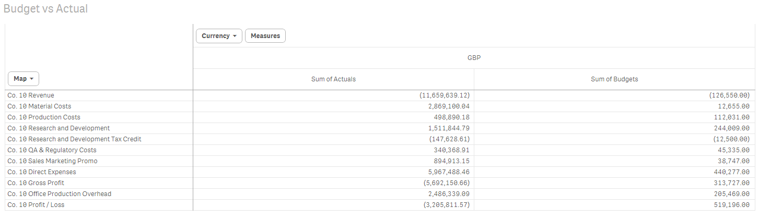

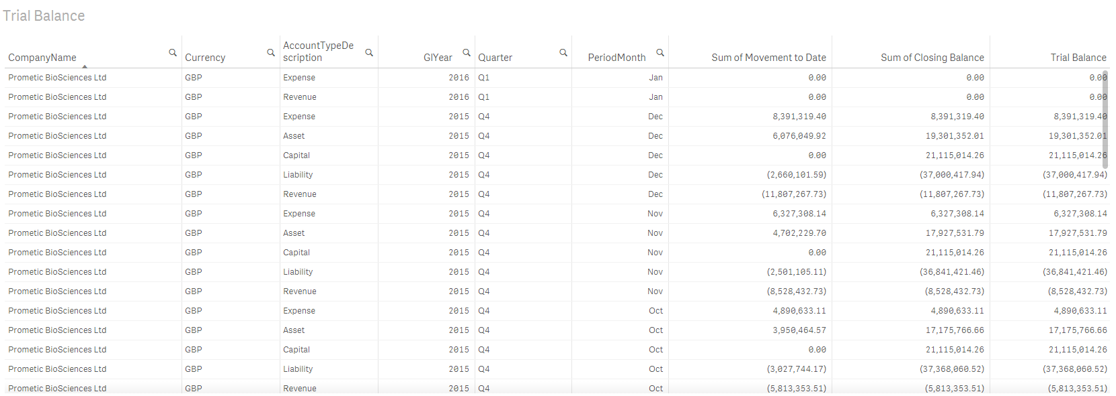

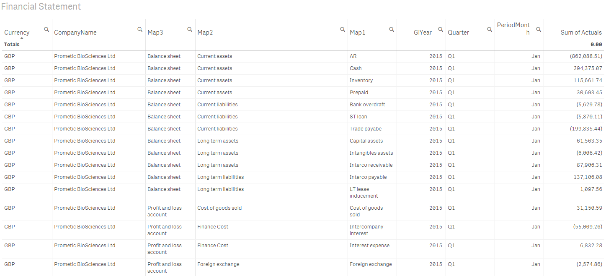

**Audience(s)**: Finance, Audit

**Estimated licenses**: 10+

**Actions to be taken**

* Define deliverables – rough design of dashboards - **complete**
* Define data from finance
  + Budget and actual data that is to be extracted from Syspro - **complete**
* Purchase of licenses
* Set up of Environment
* Creation dashboard
  + Testing by Finance

**Project Outline – Executive Dashboard**

This outline is rough and would require a full investigation to be done before times and all actions can be added

**Description** – This is four dashboards with a mashup

* The first dashboard will be a review of inventory held in the General Ledger
* The second dashboard will be a combined view of Cash for actuals and budget from the General Ledger
* The third will be a view of actuals of Cash, Accounts Receivable and Accounts Payables
* The fourth will merge data from Syspro (Budgets, Actuals & Exchange rates), SalesForce (Forecasts) and Excel (Finance Forecasts)
* The mashup has been roughly drafted as below and will bring the four dashboards into one for viewing together.

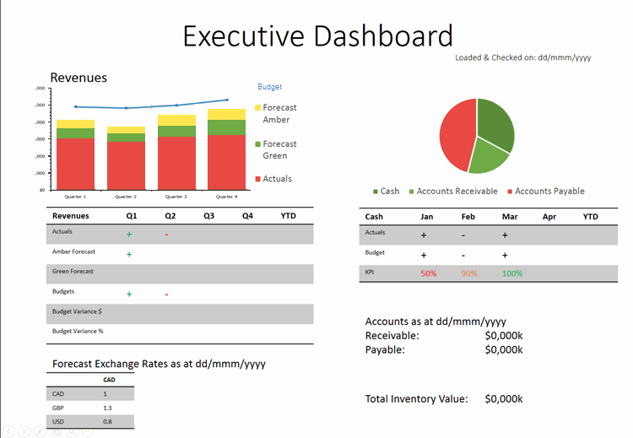

**Audience(s)**: Finance, Audit, Board, Sales

**Estimated licenses**: 25+

**Actions to be taken**

* Define deliverables – rough design of dashboards
* Define data from finance
  + forecasts to be written in a format that can be imported and held in a central location
  + Budget data that is to be extracted from Syspro
* Define data from Sales (which data to be extract from salesforce)
  + forecasts
* Purchase of licenses
* Set up of Environment
* Creation of Sales dashboard
  + Testing of Sales dashboard by Sales
* Creation of Sales/Syspro dashboard
  + Testing by Finance
  + Testing by Sales
* Creation of Mash-up

**Setup of Environment**

Every project will need the environment to be set up, this is a set process and will require decisions to be made, most of this work will need to be done by consultants from a Qlik provider. If this

Purchase/Hire of Servers

* Do we want to purchase new servers?
* Do we want to deploy to our own instance of Azure?
* Do we want to use Differentia as a Service provider?
* Do we want failover in place? Clustering?

Set up of windows Servers

Install Qlik Sense Server

Install Web Portal & Security

Create User directory

* How
* Who should have access to the site?
* Who should have access to which reports?
* Who should have access to which data?

Set up of Alerts and checks

Configure VPN access to K3

Configure Salesforce connection

Configure FTP site

Write dashboard to enable monitoring of usage

**Potential Issues**

List of issues that could cause problems with deployment of Qlik Sense

Active Directories

Different Active Directories (network security) at each office make login to the system without a username and password very difficult to implement, if possible at all.

VPN Costs

VPN access to K3 for database queries may incur additional costs from K3.

FTP Costs

FTP site to upload manually created data (such as forecasts) may incur costs from Differentia.

Support

With one member of staff internally to provide support, hosting internally any issues that occur will require existing work to be halted or raised with a third party.

Data security

If the decision is made to host financial data externally, carefully vetting will need to be done to ensure that we are comfortable with where the data is held.

General Ledger differences and maintenance

The logic for determining the General Ledger codes varies slightly between companies and the mapping of how these are to be shown in reports is not held in the ERP/Accounts system. There needs to a be a review of this process, details about how GL codes

Design

With a limited range of changes allowed, Dashboards produced in Qlik Sense will not be “pixel perfect” and some option will not be available in this

Downtime of Servers

If we decide to use cloud storage to host the environment, we will be charged for the time that the servers are up and running. If the servers are turned off out of business hours to save money, the dashboards will not be available overnight for review.